Example 1:

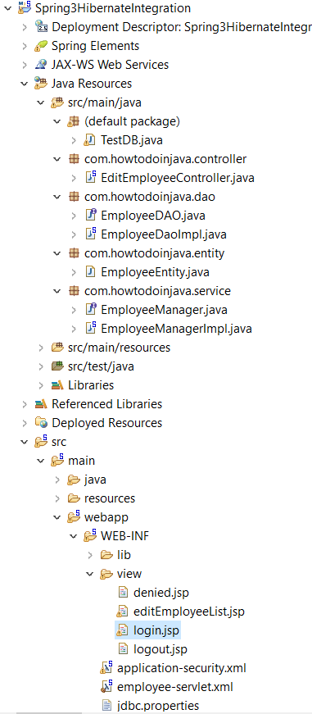

Steps to run:

1. Maven clean 🡪 maven install
2. Right click on the project 🡪 Run as 🡪 Run on server
3. In the browser open the link : <http://localhost:8081/Spring3HibernateIntegration/login>
4. Enter the wrong credentials as   
   username : demo  
   password: 1234

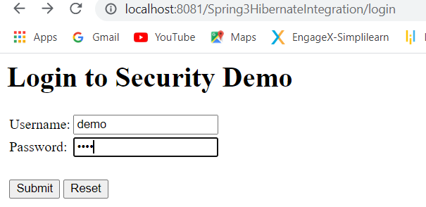 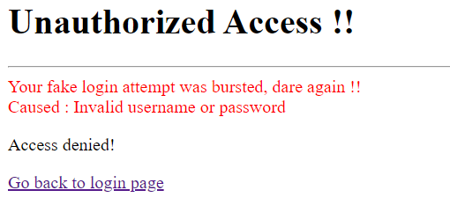

1. Now enter the correct credentials as  
   username : lokesh  
   password: password  
   (the above credentials are located inside the file ‘application-security.xml’ in project structure.

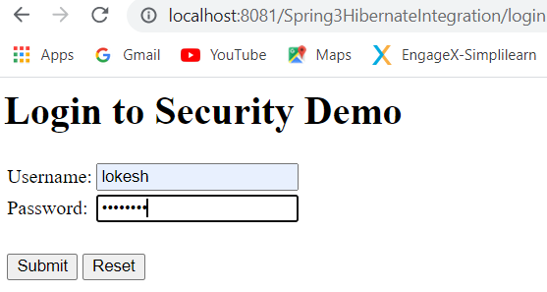  
After entering the correct credentials  
  
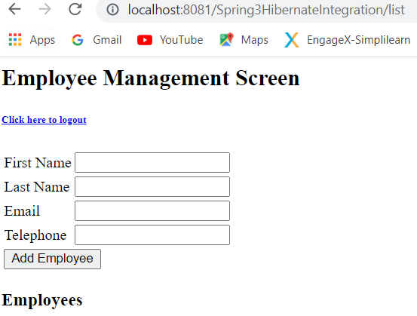🡪 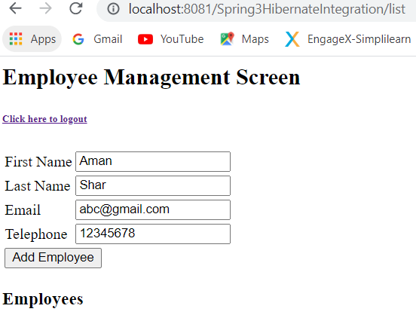   
  
Click 🡪 “Add Employee”  
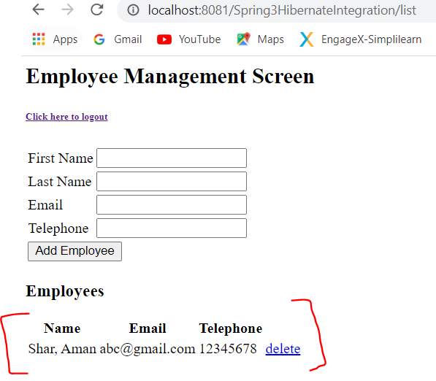  
  
Click 🡪 “delete” 🡪 employee record will be deleted as well.  
  
Now Click on the below link of the logout  
  
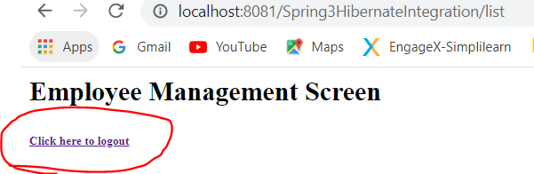 🡪 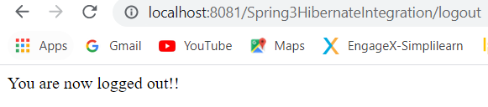

**LDAP Authentication:**

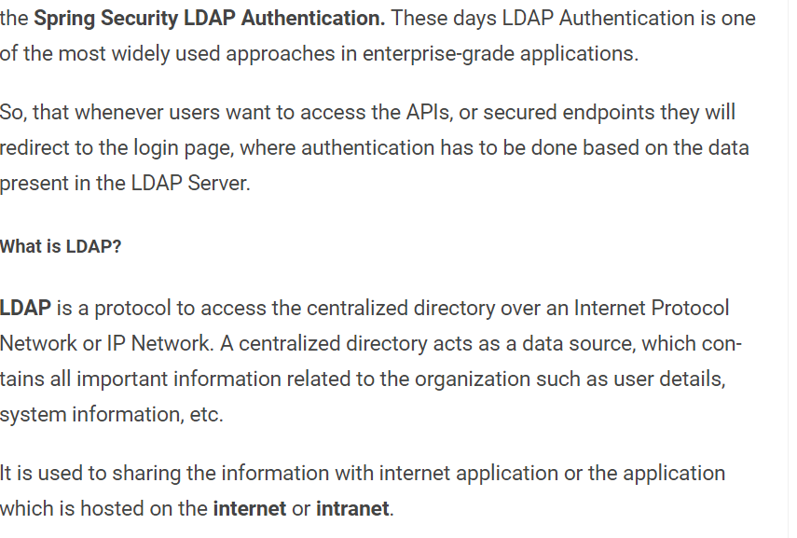

Add **Spring Security** **LDAP Authentication** Dependency in **pom.xml**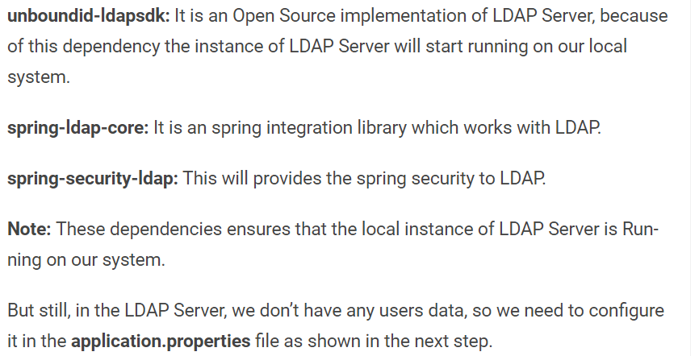

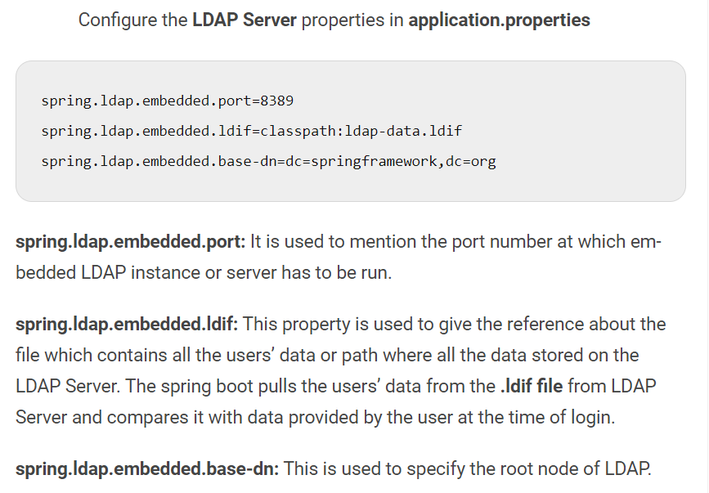

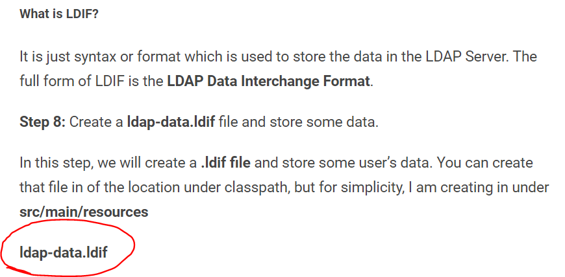

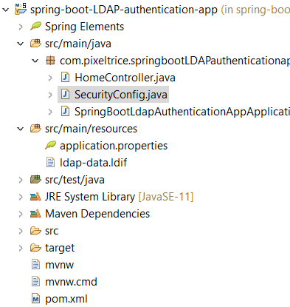

**2nd Example:**

LDAP – Auth

